Experiment 1

Program No.:1
Aim: Convert kilograms to pounds.

SOURCE CODE:
def kg_to_pounds():
"""
Converts a weight entered in kilograms to pounds.
"""
try:
kilograms = float(input("Enter the weight in kilograms: "))
pounds = kilograms * 2.20462
print(f"The weight in pounds is: {pounds:.2f}")
except ValueError:
print("Invalid input. Please enter a numerical value for weight.")
# Call the function directly to run the conversion
kg_to_pounds()

INPUT:
Enter the weight in kilograms: 12

EXPECTED OUTPUT:
The weight in pounds is: 26.46

ACTUAL OUTPUT:
The weight in pounds is: 26.46
Program No.:1.1
Aim: Write a program that uses a for loop and while loop to print the numbers 8,11,14,…,89.

SOURCE CODE:
FOR LOOP
print("Using a for loop:")
for num in range(8, 90, 3):
print(num)
WHILE LOOP
print("Using a while loop:")
num_while = 8
while num_while <= 89:
print(num_while)
num_while += 3

EXPECTED OUTPUT:
Using a while loop / For loop:
8
11
14
17
20
23
26
29
32
35
38
41
44
47
50
53
56
59
62
65
68
71
74
77
80
83
86
89
ACTUAL OUTPUT:
Using a while loop / For loop:
8
11
14
17
20
23
26
29
32
35
38
41
44
47
50
53
56
59
62
65
68
71
74
77
80
83
86
89

Program No.:1.2

Aim: Write a program to split a string into array of characters.

SOURCE CODE:
my_string = "venky"
char_list = list(my_string)
print(char_list)

EXPECTED OUTPUT:
[ 'v', 'e', 'n', 'k', 'y']
ACTUAL OUTPUT:
[ 'v', 'e', 'n', 'k', 'y']

Program 1.3:

Aim:Write a Python program to calculate the nth Fibonacci number using a function.

SOURCE CODE:
def fibonacci(n):
if n <= 0:
return "Input must be a positive integer"
elif n == 1:
return 0
elif n == 2:
return 1
else:
return fibonacci(n-1) + fibonacci(n-2)

n = 10
print(f"The {n}th Fibonacci number is: {fibonacci(n)}")

INPUT:
n = 10

EXPECTED OUTPUT:
The 10th Fibonacci number is: 34

ACTUAL OUTPUT:
The 10th Fibonacci number is: 34

Program 1.4:

Aim: Write a Python program to get the largest number from a list.

SOURCE CODE:
def get_largest_number(numbers):
if not numbers:
return None
largest = numbers[0]
for num in numbers[1:]:
if num > largest:
largest = num
return largest

my_list = [10, 45, 2, 99, 67, 88]
largest_number = get_largest_number(my_list)
print("The largest number is:", largest_number)

INPUT:
my_list = [10, 45, 2, 99, 67, 88]

EXPECTED OUTPUT:
The largest number is: 99

ACTUAL OUTPUT:
The largest number is: 99

EXPRIMENT 2
Program 2:

Aim: Write a Python program that defines a Car class with attributes like make, model, and year, and methods like start() to start the car and stop() to stop it.

SOURCE CODE:
class Car:
def __init__(self, make, model, year):
self.make = make
self.model = model
self.year = year
self.is_started = False

def start(self):
if not self.is_started:
print(f"The {self.year} {self.make} {self.model} is starting.")
self.is_started = True
else:
print(f"The {self.year} {self.make} {self.model} is already running.")

def stop(self):
if self.is_started:
print(f"The {self.year} {self.make} {self.model} is stopping.")
self.is_started = False
else:
print(f"The {self.year} {self.make} {self.model} is already stopped.")

# Demonstrating the Car class
print("--- Car Class Demonstration ---")
my_car = Car("Toyota", "Camry", 2022)
print(f"My car: {my_car.make} {my_car.model} ({my_car.year})")

my_car.start()
my_car.start()
my_car.stop()
my_car.stop()

INPUT:
Car("Toyota", "Camry", 2022)

EXPECTED OUTPUT:
--- Car Class Demonstration ---
My car: Toyota Camry (2022)
The 2022 Toyota Camry is starting.
The 2022 Toyota Camry is already running.
The 2022 Toyota Camry is stopping.
The 2022 Toyota Camry is already stopped.

ACTUAL OUTPUT:
--- Car Class Demonstration ---
My car: Toyota Camry (2022)
The 2022 Toyota Camry is starting.
The 2022 Toyota Camry is already running.
The 2022 Toyota Camry is stopping.
The 2022 Toyota Camry is already stopped.

Program 2.1:

Aim: Write a Python program that demonstrates inheritance by creating a base class Animal and derived classes like Dog and Cat with specific behaviors.

SOURCE CODE:
class Animal:
def __init__(self, name):
self.name = name

def eat(self):
print(f"{self.name} is eating.")

def sleep(self):
print(f"{self.name} is sleeping.")

class Dog(Animal):
def bark(self):
print(f"{self.name} says Woof!")

class Cat(Animal):
def meow(self):
print(f"{self.name} says Meow!")

dog1 = Dog("Buddy")
cat1 = Cat("Whiskers")

dog1.eat()
dog1.sleep()
cat1.eat()
cat1.sleep()

dog1.bark()
cat1.meow()

.

INPUT:
Dog("Buddy"), Cat("Whiskers")

EXPECTED OUTPUT:
Buddy is eating.
Buddy is sleeping.
Whiskers is eating.
Whiskers is sleeping.
Buddy says Woof!
Whiskers says Meow!

ACTUAL OUTPUT:
Buddy is eating.
Buddy is sleeping.
Whiskers is eating.
Whiskers is sleeping.
Buddy says Woof!
Whiskers says Meow!

Program 2.2:
Aim: Write a Python program that demonstrates error handling using the try-except block to handle division by zero.
SOURCE CODE:
def safe_divide(numerator, denominator):
try:
result = numerator / denominator
print(f"The result of {numerator} / {denominator} is: {result}")
except ZeroDivisionError:
print(f"Error: Cannot divide by zero! Attempted {numerator} / {denominator}")
except TypeError:
print("Error: Invalid input types. Please provide numbers.")

print("--- Error Handling Demonstration ---")
safe_divide(10, 2)
safe_divide(10, 0)
safe_divide(5, "abc")
INPUT:
safe_divide(10, 2)
safe_divide(10, 0)
safe_divide(5, "abc")

EXPECTED OUTPUT:
The result of 10 / 2 is: 5.0
Error: Cannot divide by zero! Attempted 10 / 0
Error: Invalid input types. Please provide numbers.
ACTUAL OUTPUT:
The result of 10 / 2 is: 5.0
Error: Cannot divide by zero! Attempted 10 / 0
Error: Invalid input types. Please provide number
Program 2.3:

Aim:
Write a Python program that defines a base class Animal with a method make_sound() and derived classes Dog, Cat, and Bird that override the method to produce different sounds. Demonstrate polymorphism.
SOURCE CODE:
class Animal:
def make_sound(self):
raise NotImplementedError("Subclass must implement abstract method 'make_sound'")

class Dog(Animal):
def make_sound(self):
return "Woof! Woof!"

class Cat(Animal):
def make_sound(self):
return "Meow!"

class Bird(Animal):
def make_sound(self):

return "Chirp! Chirp!"

print("--- Polymorphism Demonstration ---")
animals = [Dog(), Cat(), Bird()]

for animal in animals:
print(f"An animal makes sound: {animal.make_sound()}")

INPUT:
animals = [Dog(), Cat(), Bird()]

EXPECTED OUTPUT:
--- Polymorphism Demonstration ---
An animal makes sound: Woof! Woof!
An animal makes sound: Meow!
An animal makes sound: Chirp! Chirp!

ACTUAL OUTPUT:
--- Polymorphism Demonstration ---
An animal makes sound: Woof! Woof!
An animal makes sound: Meow!
An animal makes sound: Chirp! Chirp!

Program No.: 2.4
Aim:
Demonstrate error handling in Python using the try-except block to handle division by zero.
SOURCE CODE:
def safe division():
"""
Demonstrates error handling for division by zero.
"""
try:
numerator = float(input("Enter numerator: "))
denominator = float(input("Enter denominator: "))
result = numerator / denominator
print(f"Result: {result:.2f}")
except ZeroDivisionError:
print("Error: Division by zero is not allowed.")
except ValueError:
print("Invalid input. Please enter numerical values only.")

# Run the function
safe_division()
INPUT (Case 1):
Enter numerator: 10
Enter denominator: 2
EXPECTED / ACTUAL OUTPUT (Case 1):
Result: 5.00
INPUT (Case 2):
Enter numerator: 10
Enter denominator: 0
EXPECTED / ACTUAL OUTPUT (Case 2):
Error: Division by zero is not allowed.
Experiment 3
Program No.: 3.1
Aim:
Demonstrate the use of NumPy methods for array creation, element-wise operations, comparisons, and conversions.
SOURCE CODE:
import numpy as np
# Get help on add
help(np.add)
# Check if none are zero
arr = np.array([1, 2, 3, 4, 5])
print("Array:", arr)
print("None of the elements is zero:", np.all(arr))
# Comparisons
a = np.array([1, 2, 3, 4])
b = np.array([2, 2, 1, 4])
print("Greater:", np.greater(a, b))
print("Greater or Equal:", np.greater_equal(a, b))
print("Less:", np.less(a, b))
print("Less or Equal:", np.less_equal(a, b))
print("Equal:", np.equal(a, b))
print("Allclose:", np.allclose(a, b))
# Create arrays
zeros_array = np.zeros(5)
ones_array = np.ones(5)
linspace_array = np.linspace(0, 10, 5)
print("Zeros array:", zeros_array)
print("Ones array:", ones_array)
print("Linspace array:", linspace_array)
# Convert to list
array_list = a.tolist()
print("Array converted to list:", array_list)

INPUT:
Predefined arrays in code.

EXPECTED / ACTUAL OUTPUT:
Array: [1 2 3 4 5]
None of the elements is zero: True
Greater: [False False True False]
Greater or Equal: [False True True True]
Less: [ True False False False]
Less or Equal: [ True True False True]
Equal: [False True False True]
Allclose: False
Zeros array: [0. 0. 0. 0. 0.]
Ones array: [1. 1. 1. 1. 1.]
Linspace array: [ 0. 2.5 5. 7.5 10. ]
Array converted to list: [1, 2, 3, 4]

Program No.: 3.2
Aim:
Demonstrate NumPy methods for extracting, analyzing, and summarizing array data.
SOURCE CODE:
import numpy as np
arr = np.array([1, 3, 5, 7, 3, 5, 9, 2, 5])
num = 4
less_than_num = arr[arr < num]
greater_than_num = arr[arr > num]
print("Original array:", arr)
print("Numbers less than 4:", less_than_num)
print("Numbers greater than 4:", greater_than_num)
print("Maximum value:", np.max(arr))
print("Minimum value:", np.min(arr))
print("Index of maximum value:", np.argmax(arr))
print("Index of minimum value:", np.argmin(arr))
print("Unique elements:", np.unique(arr))
print("Count of each element:", np.bincount(arr))
print("Representation of array:", np.array_repr(arr))

INPUT:
Predefined array and threshold.

EXPECTED / ACTUAL OUTPUT:
Original array: [1 3 5 7 3 5 9 2 5]
Numbers less than 4: [1 3 3 2]
Numbers greater than 4: [5 7 5 9 5]
Maximum value: 9
Minimum value: 1
Index of maximum value: 6
Index of minimum value: 0
Unique elements: [1 2 3 5 7 9]
Count of each element: [0 1 1 2 0 3 0 1 0 1]
Representation of array: array([1, 3, 5, 7, 3, 5, 9, 2, 5])
Experiment 4

Program No.: 4.1
Aim:
To create and display a one-dimensional Pandas Series and convert it to a Python list.

SOURCE CODE:
import pandas as pd
# Create and display a Pandas Series
data_list = pd.Series([10, 20, 30, 40, 50])
print("Pandas Series created from a list:")
print(data_list)
# Convert the Series to a Python list and display type
data_list_converted = data_list.tolist()
print("\nConverted to Python list:", data_list_converted)
print("Type of converted object:", type(data_list_converted))

INPUT:
Predefined list: [10, 20, 30, 40, 50]

EXPECTED / ACTUAL OUTPUT:
Pandas Series created from a list:
0 10
1 20
2 30
3 40
4 50
dtype: int64
Converted to Python list: [10, 20, 30, 40, 50]
Type of converted object: <class 'list'>

Program No.: 4.2

Aim:
Create and manipulate a Pandas DataFrame from a dictionary, update values, add a new column, and display column headers.
SOURCE CODE:
import pandas as pd
import numpy as np
exam_data = {
'name': ['Anastasia', 'Dima', 'Katherine', 'James', 'Emily', 'Michael', 'Matthew', 'Laura', 'Kevin', 'Jonas'],
'score': [12.5, 9, 16.5, np.nan, 9, 20, 14.5, np.nan, 8, 19],
'attempts': [1, 3, 2, 3, 1, 1, 2, 1, 1, 2],
'qualify': ['yes', 'no', 'yes', 'no', 'no', 'yes', 'yes', 'no', 'yes', 'yes']
}
labels = ['a','b','c','d','e','f','g','h','i','j']
df = pd.DataFrame(exam_data, index=labels)
print("DataFrame created from dictionary:")
print(df)
df.loc['d','name'] = 'Suresh'
print("\nDataFrame after updating name 'James' to 'Suresh':")
print(df)
salaries = [50000, 60000, 75000, 45000, 55000, 80000, 70000, 48000, 62000, 78000]
df['salary'] = salaries
print("\nDataFrame after adding 'salary' column:")
print(df)
column_headers = df.columns.tolist()
print("\nList of column headers:", column_headers)
INPUT:
Predefined dictionary with student data.

EXPECTED / ACTUAL OUTPUT:
DataFrame created from dictionary:
name score attempts qualify
a Anastasia 12.5 1 yes
b Dima 9.0 3 no
c Katherine 16.5 2 yes
d James NaN 3 no
e Emily 9.0 1 no
f Michael 20.0 1 yes
g Matthew 14.5 2 yes
h Laura NaN 1 no
i Kevin 8.0 1 yes
j Jonas 19.0 2 yes
DataFrame after updating name 'James' to 'Suresh':
name score attempts qualify
a Anastasia 12.5 1 yes
b Dima 9.0 3 no
c Katherine 16.5 2 yes
d Suresh NaN 3 no
e Emily 9.0 1 no
f Michael 20.0 1 yes
g Matthew 14.5 2 yes
h Laura NaN 1 no
i Kevin 8.0 1 yes
j Jonas 19.0 2 yes
DataFrame after adding 'salary' column:
name score attempts qualify salary
a Anastasia 12.5 1 yes 50000
b Dima 9.0 3 no 60000
c Katherine 16.5 2 yes 75000
d Suresh NaN 3 no 45000
e Emily 9.0 1 no 55000
f Michael 20.0 1 yes 80000
g Matthew 14.5 2 yes 70000
h Laura NaN 1 no 48000
i Kevin 8.0 1 yes 62000
j Jonas 19.0 2 yes 78000
List of column headers: ['name', 'score', 'attempts', 'qualify', 'salary']

Experiment 5

Program No.: 5.1
Aim:
Create a series of plots to analyze a given dataset.
SOURCE CODE:
import matplotlib.pyplot as plt
import numpy as np
x = np.linspace(0, 2 * np.pi, 100)
y = np.sin(x)
y2 = np.cos(x)
y3 = np.sin(x) * np.cos(x)
plt.figure(figsize=(12, 4))
plt.subplot(1, 3, 1)
plt.plot(x, y, color='blue')
plt.title('Sine Wave')
plt.xlabel('X-axis')
plt.ylabel('Y-axis')
plt.subplot(1, 3, 2)
plt.plot(x, y2, color='green')
plt.title('Cosine Wave')
plt.xlabel('X-axis')
plt.ylabel('Y-axis')
plt.subplot(1, 3, 3)
plt.plot(x, y3, color='red')
plt.title('Product of Sine and Cosine')
plt.xlabel('X-axis')
plt.ylabel('Y-axis')
plt.tight_layout()
plt.show()

INPUT:
• x → 100 points from 0 to 2π.
• y, y2, y3 → Calculated using sin(x), cos(x), and sin(x)*cos(x).

EXPECTED / ACTUAL OUTPUT:
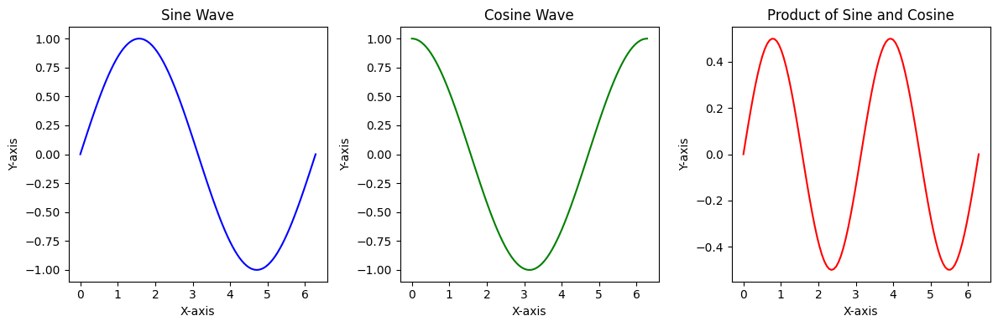

Program No.: 5.2
Aim:
Generate a subplot layout with various plot types (scatter, line, bar).

SOURCE CODE:
import matplotlib.pyplot as plt
import numpy as np
import pandas as pd
data = {'Category': ['A', 'B', 'C', 'D'],
'Value1': [10, 25, 15, 30],
'Value2': [15, 20, 25, 10]}
df = pd.DataFrame(data)
x_scatter = np.random.rand(50)
y_scatter = np.random.rand(50)
x_line = np.arange(10)
y_line = np.random.randint(1, 10, size=10)
fig, axes = plt.subplots(2, 2, figsize=(10, 8))
axes[0, 0].scatter(x_scatter, y_scatter)
axes[0, 0].set_title('Scatter Plot')
axes[0, 0].set_xlabel('X-axis')
axes[0, 0].set_ylabel('Y-axis')
axes[0, 1].plot(x_line, y_line, marker='o')
axes[0, 1].set_title('Line Plot')
axes[0, 1].set_xlabel('X-axis')
axes[0, 1].set_ylabel('Y-axis')
axes[1, 0].bar(df['Category'], df['Value1'])
axes[1, 0].set_title('Bar Chart')
axes[1, 0].set_xlabel('Category')
axes[1, 0].set_ylabel('Value1')
axes[1, 1].set_visible(False)
plt.tight_layout()
plt.show()
INPUT:
- categories: ['A', 'B', 'C', 'D']
- Random numeric arrays (x_scatter, y_scatter, y_line)
- Tabular data (Value1, Value2)
EXPECTED / ACTUAL OUTPUT:
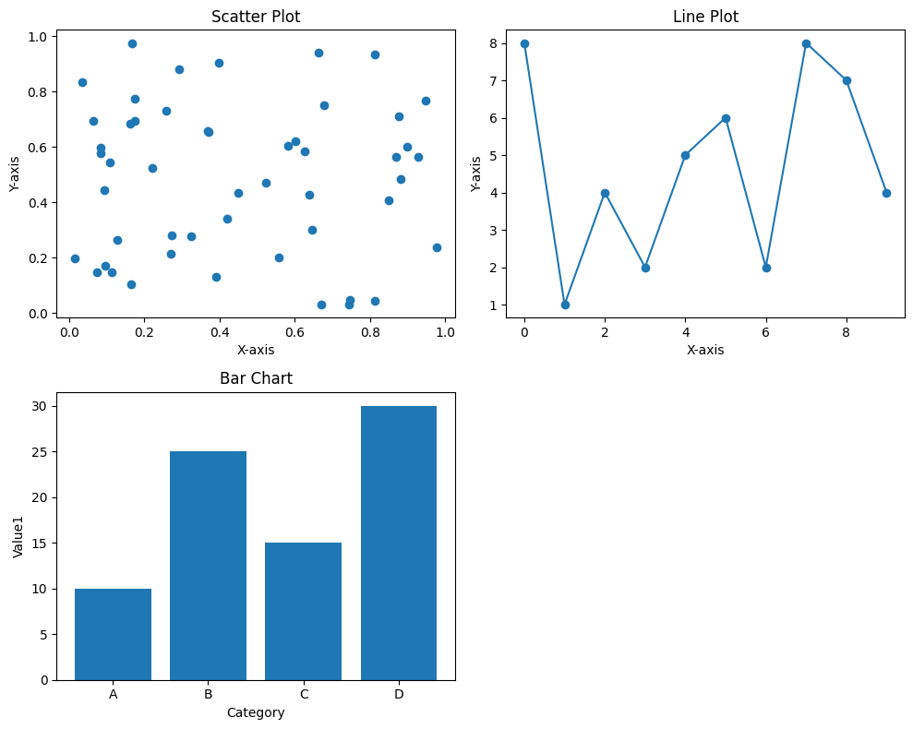

Program No.: 5.3
Aim:
Visualize time-series data and customize axis labels and date formats.
SOURCE CODE:
import matplotlib.pyplot as plt
import pandas as pd
import numpy as np
dates = pd.to_datetime(pd.date_range(start='2024-01-01', periods=100, freq='D'))
sales_data = np.random.randint(100, 500, size=100) + np.sin(np.arange(100) * 0.2) * 50
df = pd.DataFrame({'Date': dates, 'Sales': sales_data})
df = df.set_index('Date')
plt.figure(figsize=(12, 6))
plt.plot(df.index, df['Sales'])
plt.xlabel('Date')
plt.ylabel('Sales')
plt.title('Daily Sales Over Time')
df.plot(y='Sales', figsize=(12, 6), title='Daily Sales Over Time')
plt.show()
INPUT:
- Randomly generated daily sales data for 100 days starting from 2024-01-01

EXPECTED / ACTUAL OUTPUT:
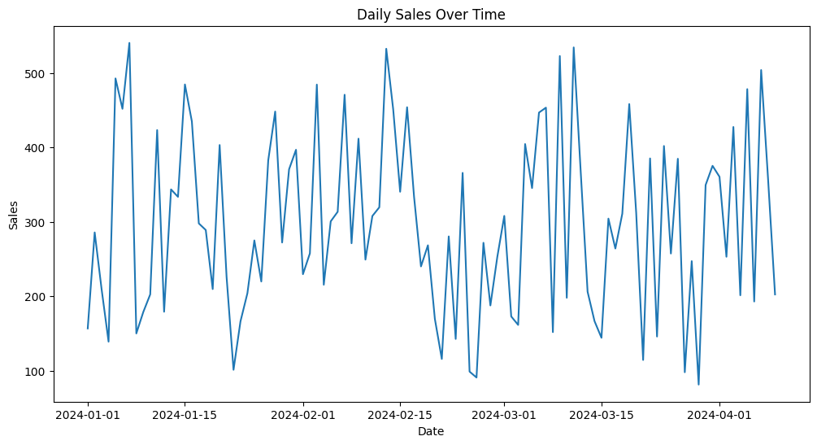

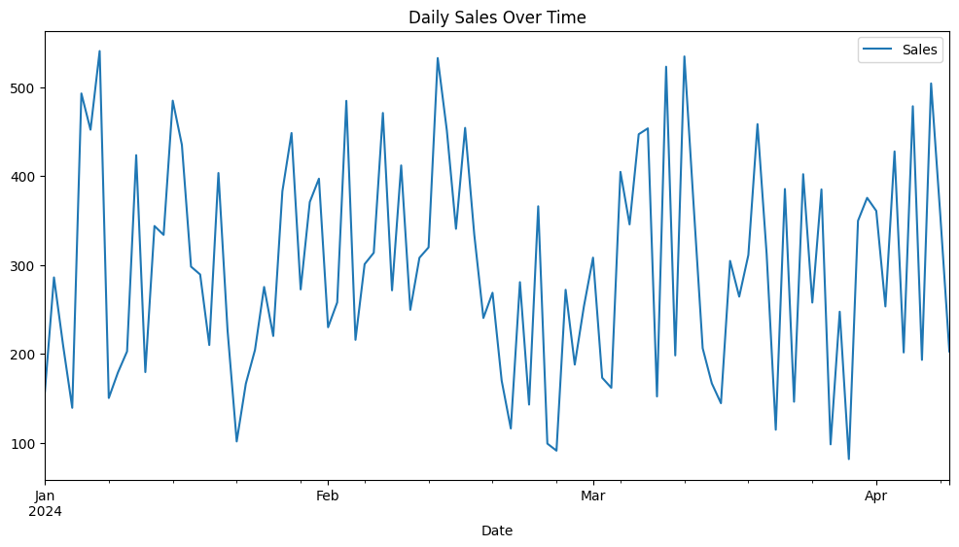

Program No.: 5.4
Aim:
Create a 3D plot.
SOURCE CODE:
import matplotlib.pyplot as plt
import numpy as np
from mpl_toolkits.mplot3d import Axes3D
np.random.seed(42)
x = np.random.rand(50)
y = np.random.rand(50)
z = np.random.rand(50)
fig = plt.figure(figsize=(8, 6))
ax = fig.add_subplot(111, projection='3d')
ax.scatter(x, y, z)
ax.set_xlabel('X-axis')
ax.set_ylabel('Y-axis')
ax.set_zlabel('Z-axis')
ax.set_title('3D Scatter Plot')
plt.show()
INPUT:
Randomly generated 3D data points for x, y, and z, each containing 50 values between 0 and 1.
EXPECTED / ACTUAL OUTPUT:
